REPUBLIC OF KIRIBATI

AGRICULTURE AND  
LIVESTOCK DIVISION

Agriculture Strategic Plan

2013-2016

© Secretariat of the Pacific Community (SPC), 2013

All rights for commercial / for profit reproduction or translation, in any form, reserved. SPC authorises the partial reproduction or translation of this material for scientific, educational or research purposes, provided that SPC and the source document are properly acknowledged. Permission to reproduce the document and/or translate in whole, in any form, whether for commercial / for profit or non-profit purposes, must be requested in writing. Original SPC artwork may not be altered or separately published without permission.

Original text: English

Secretariat of the Pacific Community Cataloguing-in-publication data

Agriculture strategic plan 2013-2018 / Republic of Kiribati Agriculture and Livestock Division

1. Agriculture — Planning — Kiribati.
2. Sustainable agriculture — Kiribati.
3. Food supply — Kiribati.
4. Biosecurity — Kiribati.

I. Title II. Kiribati Agriculture and Livestock Division III. Secretariat of the Pacific Community

338.160 996 81 AACR2

ISBN: 978-982-00-0628-7

CONTENTS

|  |  |  |
| --- | --- | --- |
| **Abbreviations** | | |
| **01** | Introduction | **7** |
| **02** | Kiribati And Its Challenges | **9** |
| **03** | Mission And Objectives | **13** |
| **04** | Outputs | **15** |
| **05** | Monitoring And Evaluation | **19** |
| **06** | Logical Framework Matrix | **21** |

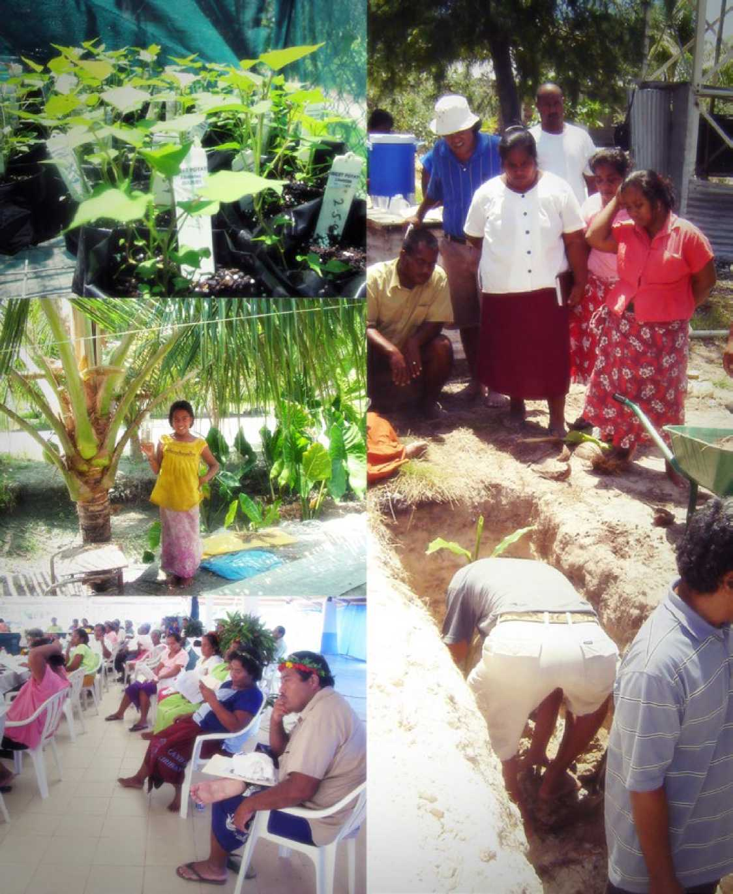

FOREWORD

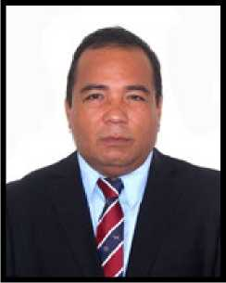It gives me great pleasure to introduce the Agriculture Strategic Plan 2013 to 2016. To provide a foreword to such an important document is indeed a momentous occasion for me as Minister responsible for Agriculture. The Ministry, and in particular the Agriculture and Livestock Department,must attach considerable importance to this plan, as it will now serve as the principle guide to their operations over the next 5 years.

Agriculture is our livelihood and it is the mainstay for all the people of Kiribati, especially our communities on the outer islands. Food security, as echoed by many, is everybody’s business. In this regard, I wish to recall the recent and current issue of basic food shortage and soaring food prices that has hit Kiribati and has been badly felt by all I-Kiribati since 2007. We have witnessed the outcry of our people, in particular those who live on South Tarawa. Families panicked and worried that they will not have any or sufficient food to feed themselves. Government was worried that people will blame them for this problem. The business communities also tried their best to resolve the problem. This is a clear picture and message to all of us, that food security requires the effort of everyone. If we want to stay healthy and happy we must accept this reality and start to work together.

We should start utilizing our limited lands by planting local food crops that will feed us on a daily basis. We must encourage our communities to continue to cultivate their coconut and babai plantations. Government must provide more initiatives and incentives to engage the youth in local food production.

I realize that the main cause of food shortage is the heavy dependence on imported grains such as rice, flour and sugar, coupled with insufficient production of local food. Our people have depended for too long on these imported foods to the point where these foreign foods have become national staple diets. This dependency is very risky, particularly nowadays when climate change is impacting negatively on food production patterns globally. We are fully aware of the fact that grain-growing countries in Asia and South America are facing great difficulties, and are looking at alternative crops that provide better returns. If this happens the people of Kiribati will starve.

It is therefore important that we take immediate steps to address this risk by reverting to our traditional food crops which are always available and more nutritious. For us the only way out of this dilemma is to come to the realization that growing traditional food crops will provide us with unlimited and nutritious supplies of fresh foods that will both address our food shortage and health problems.

The launching of this Strategic Plan is a historic feat by the Division. This is the first time that a plan is being applied to provide guidance in our efforts to address the emerging and challenging issues of food nutrition and nutrition insecurity. The document will provide policy guidelines and direction for the Agriculture Sector to implement programs that will focus on the needs related to increase agriculture productivity. The Strategic Plan will also provide a clear direction to the sector to align its objectives in a well-coordinated and integrated approach. The used of funds and application of appropriate technologies to address specific issues faced by the communities will be transparent. In this way, the Strategic Plan will also provide avenue for donors to complement what the Division is doing in order to maximize benefits to the community.

In this regard, I wish to acknowledge the support of the Secretariat of the Pacific Community through the Land Resource Division for this achievement and also for the financial support during the consultation and finalization of this document. I wish to give my sincere gratitude and special tribute to the mayors, women representatives, youths, government ministries and stakeholders who participatedin and provided guidance during the consultation. Last but not the least I acknowledge the effort and sacrifice rendered by the hard working team from the Agriculture Division who, through their dedication and hard work have enabled the timely completion of this Plan.

Te Mauri, Te Raoi ao Te Tabomoa.



Kamrabwa

**Honorable Tiarite G. Kwong**

**Minister of Environment, Lands and Agricultural Development**

ABBREVIATIONS

|  |  |
| --- | --- |
| **ACIAR** | Australian Centre for International Agricultural Research |
| **ALD** | Agriculture and Livestock Division |
| **DSAP** | Development of Sustainable Agriculture in the Pacific |
| **FAO** | Food and Agricultural Organisation of the United Nations |
| **KPA** | Key Policy Area |
| **LRD** | Land Resources Division of the Secretariat of the Pacific Community |
| **PICTs** | Pacific Island Countries and Territories |
| **PPPO** | Pacific Plant Protection Organisation |
| **SPC** | Secretariat of the Pacific Community |

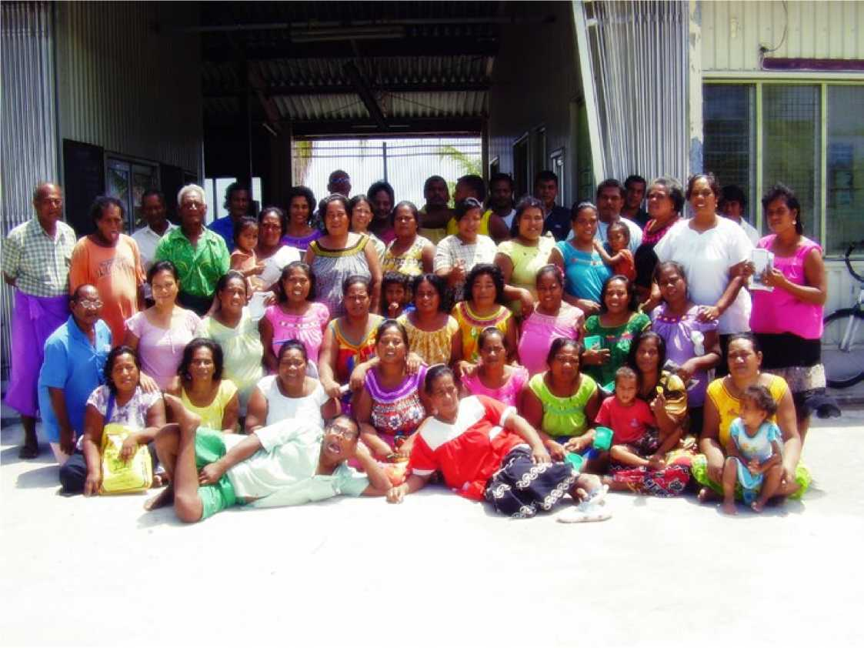

01

INTRODUCTION

The strategic plan for Agriculture and Livestock Division (ALD) of the Kiribati Ministry of Environment, Land and Agricultural Development was developed in a participatory manner with input from all major stakeholders in the country.

These stakeholders are representatives of various government ministries, including the Ministry of Internal and Social Affairs; the Ministry of Commerce, Industry and Cooperatives; the Ministry of Finance and Economic Development, Ministry of Health and Medical Services; mayors and councillors; non-governmental organisations; exporters of agricultural produce; women; youth; church groups; and selected farmers. Participatory rural appraisal tools were used to ensure the involvement of all stakeholders and to start building partnerships at the beginning of the process. This approach also ensured that the stakeholders shared a feeling of empowerment and ownership right from the planning phase, which should follow through to implementation of the work plans.

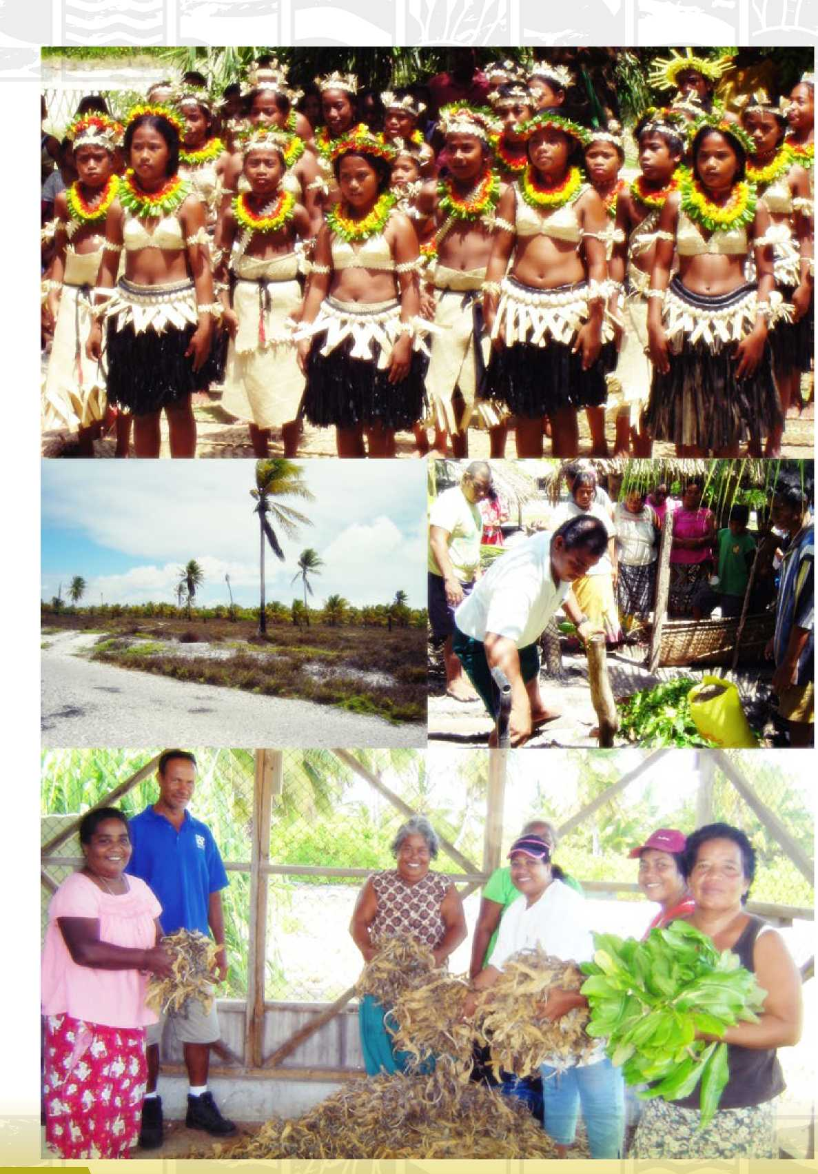



02

'S CHALLENGES

Kiribati Development Background

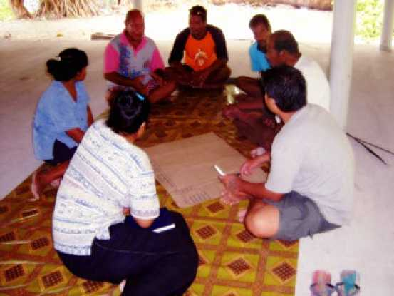Kiribati is a small atoll island state in the northern Pacific, made up of 33 scattered coral atolls. It has relatively few natural resources on which to base its development. Once the commercially viable deposits of phosphate were exhausted, only copra and fish remained as sources of export earnings for the country. Economic development is constrained by the limited skilled workforce, weak infrastructure and remoteness from international markets.

The Government of Kiribati has set the overall aim of development as an increase in kabwaia (prosperity, well­being), tibwatibwaan raoi (equitably distributed) among the people of Kiribati according to principles of good governance. However, Kiribati’s economy faces significant constraints inherent to atoll islands. Several of these constraints affect agricultural development, including the country’s smallness, remoteness and geographical fragmentation, and its harsh natural environment with very poor soil conditions.

The 2010 census determined that the total population was 103,058. This compares to 92,533 persons in 2005 and reflects an increase of 11.4 per cent or 10,525 persons. This increase in population represents an average annual rate of growth of 2.28 per cent. South Tarawa’s 50,182 residents represent 48.7 per cent of the total Kiribati population. The outer islands of the Gilbert group were home to 45,299 people, and another 7,577 lived in the Line and Phoenix groups.

Trade statistics in 2007 showed an increase in exports due to exports of ‘coconut crude oil’. This product was responsible for 51% of total exports from Kiribati that year, more than triple the amount exported the previous year. Coconut crude oil is a newly established product, introduced in 2004, which has contributed a lot to the economy of Kiribati. Copra was once a major export, but the amount exported decreased dramatically in 2007, amounting to only $0.9 million - just 7% of exports. More recently, however, the export of coconut crude oil has also declined, demonstrating the vulnerability of an economy that relies on one product for export.

Challenges

Pacific Island countries and territories (PICTs) have identified a number of priority challenges for atoll agricultural development at regional meetings such as the meetings of Heads of Agriculture and Forestry Services and Heads of Livestock. Many of these challenges are faced by Kiribati.

Challenges for Crop Production

Crop farming is mostly for subsistence in Kiribati, with most of the traditional agriculture practised in the outer islands. The major challenges to crop farming are:

1. Nature of the soils.

The soils are calcareous, shallow, alkaline and coarse textured. The soil fertility is dependent on the organic matter content. Supplies of calcium and magnesium are abundant, but imbalances with potassium and micronutrients cause significant plant nutrition problems. Nitrogen and phosphorus are also generally limited except where there are old bird guano deposits.

1. Water availability.

On the atolls both the limited quantity of water available and the quality of the water are limiting. Underground freshwater lenses are the major source of water on the larger atolls. Where there is underground water, it is either in danger of contamination with brackish water if overexploited, or it is already brackish. Harvesting rainfall is an important option for both domestic and agricultural use.

^^Competition for water by different sectors (crops, animals and human) is putting great pressure on the limited water resources on the atolls.

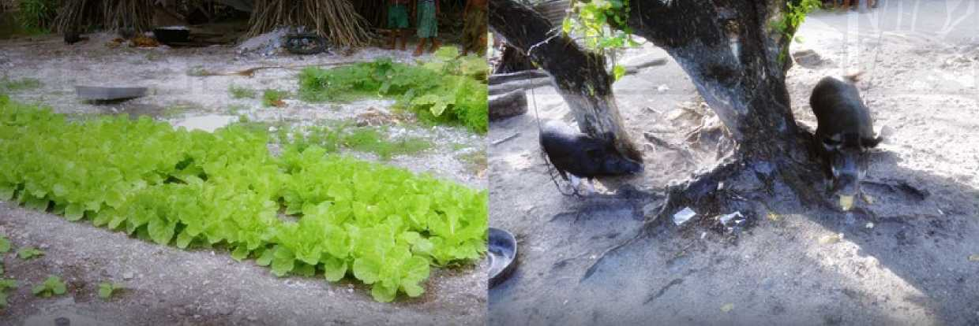

1. Narrow genetic base.

There are few food plants that are native to atolls and are tolerant of harsh atoll conditions, like pandanus. Coconut, Colocasia and Cytosperma taros, banana (Musa spp) and breadfruit (Artocarpus altilis) were introduced by indigenous people. The cultivation of these plants requires control and modification of the environment. Most of the introduced food plant and forestry species are not very tolerant of salinity and harsh atoll conditions.

Some of the varieties of species like pandanus, taro, breadfruit, coconuts, dwarf banana, traditional fruits and sources of traditional medicines are now endangered. Mangroves and some of the coastal and inland forests are disappearing. In Kiribati there were over 200 varieties of edible pandanus, which used to produce food even in severest of droughts, but many are disappearing now. Oral history supports this observation. There is not enough replanting to replace the pandanus destroyed by deforestation and fire outbreaks, and young people tend to ignore this traditional food source. Natural biodiversity on atolls is narrow, and some of it is starting to be lost, endangering food security.

1. Pests and diseases.

A major problem with introduced crops is their susceptibility to pests and diseases. Traditional crops like coconuts and breadfruit also have pest and disease problems.

1. Costs of farm inputs.

With the increasing incidence of pests and diseases and poor soil conditions, farm inputs to control these problems need to be available all the time and at affordable prices.

Challenges for Forestry

The major challenge for forestry is the disappearance of native forest trees and traditional agroforestry systems. Strengthening the capacity of both field staff and farmers to implement sustainable forest management and developing appropriate forestry and agroforestry policies and strategies should be a focus of the strategic plan.

Challenges for Livestock

There are limited choices for livestock production on atolls. Most common are smaller animals - pigs, poultry, ducks and fish. The traditional breeds of small animals raised on atolls are disappearing. Culling superior animals for social obligations contributed significantly to the loss of traditional breeds. Competition with humans for food and water is another challenge for livestock production. There are also increasing incidences of animal pests and diseases. A pressing issue on Kiribati atolls is managing waste from livestock.

Erosion of Traditional Knowledge

Traditional knowledge of how to hunt, fish, farm and care for domestic and wild plants and animals is also eroding. Even traditional forms of food preparation and preservation are unknown to many young people.

Today most of the atolls are dependent on imported foods, which are mostly inferior in quality. This has contributed to a rapid increase in the levels of diabetes, heart disease, stroke, obesity, dental disease and cancer.



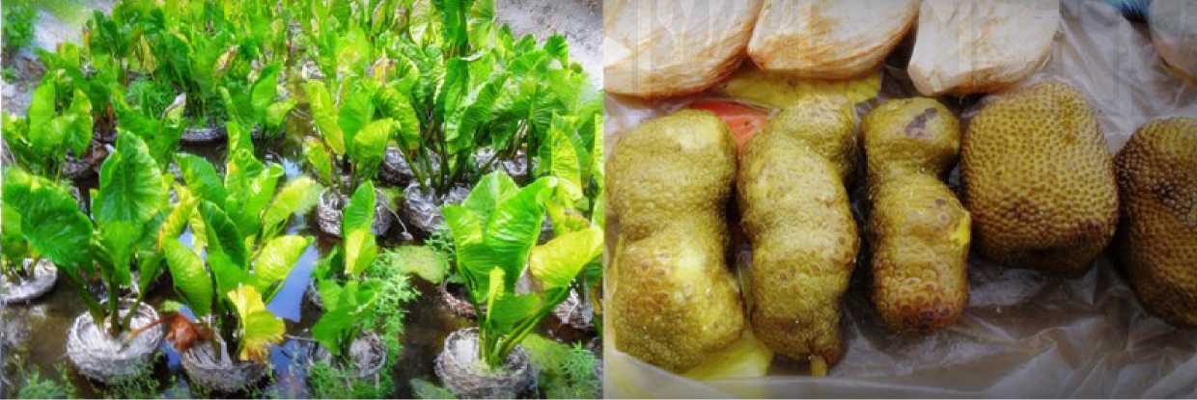Trade and Marketing

Currently a shift is taking place away from the traditional copra export in favour of the export of coconut oil. There are opportunities in the domestic market for added value products like breadfruit flour and for selling fresh agricultural produce from the outer islands in South Tarawa.

Climate Change

There is increasing concern over the possible impacts of climate change on countries with substantial areas of land at or close to sea level. Kiribati atolls fall into this category as they are rarely more than 3 metres above sea level. The risks come from potential sea level rise, increasing salinity, warmer atmosphere and possibly reduced precipitation.

Capacity Building

Currently, most of the atolls have limited human resources and few people with adequate qualifications to successfully undertake farming under these challenging conditions. There is also very limited human resource development, including a general lack of vocational and academic training in agriculture and forestry.

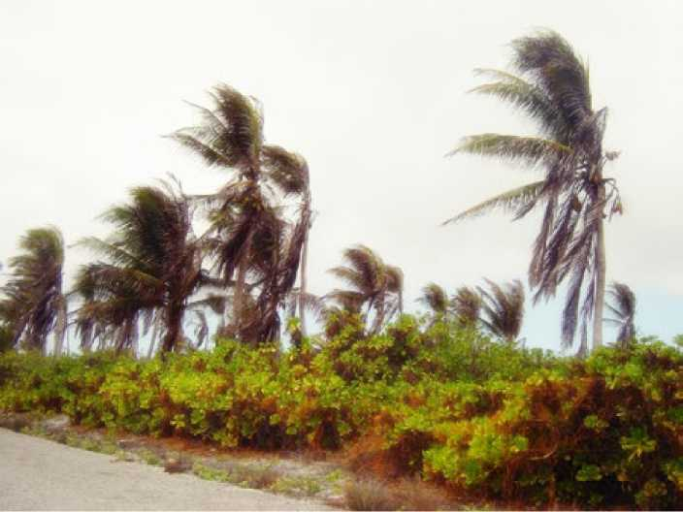Partnerships

It must be emphasised that successful implementation of the strategic plan will be dependent on the strength of partnerships among the key stakeholders. It is therefore essential that the key stakeholders are identified early and engaged in the development, implementation, and monitoring and evaluation of the strategic plan.

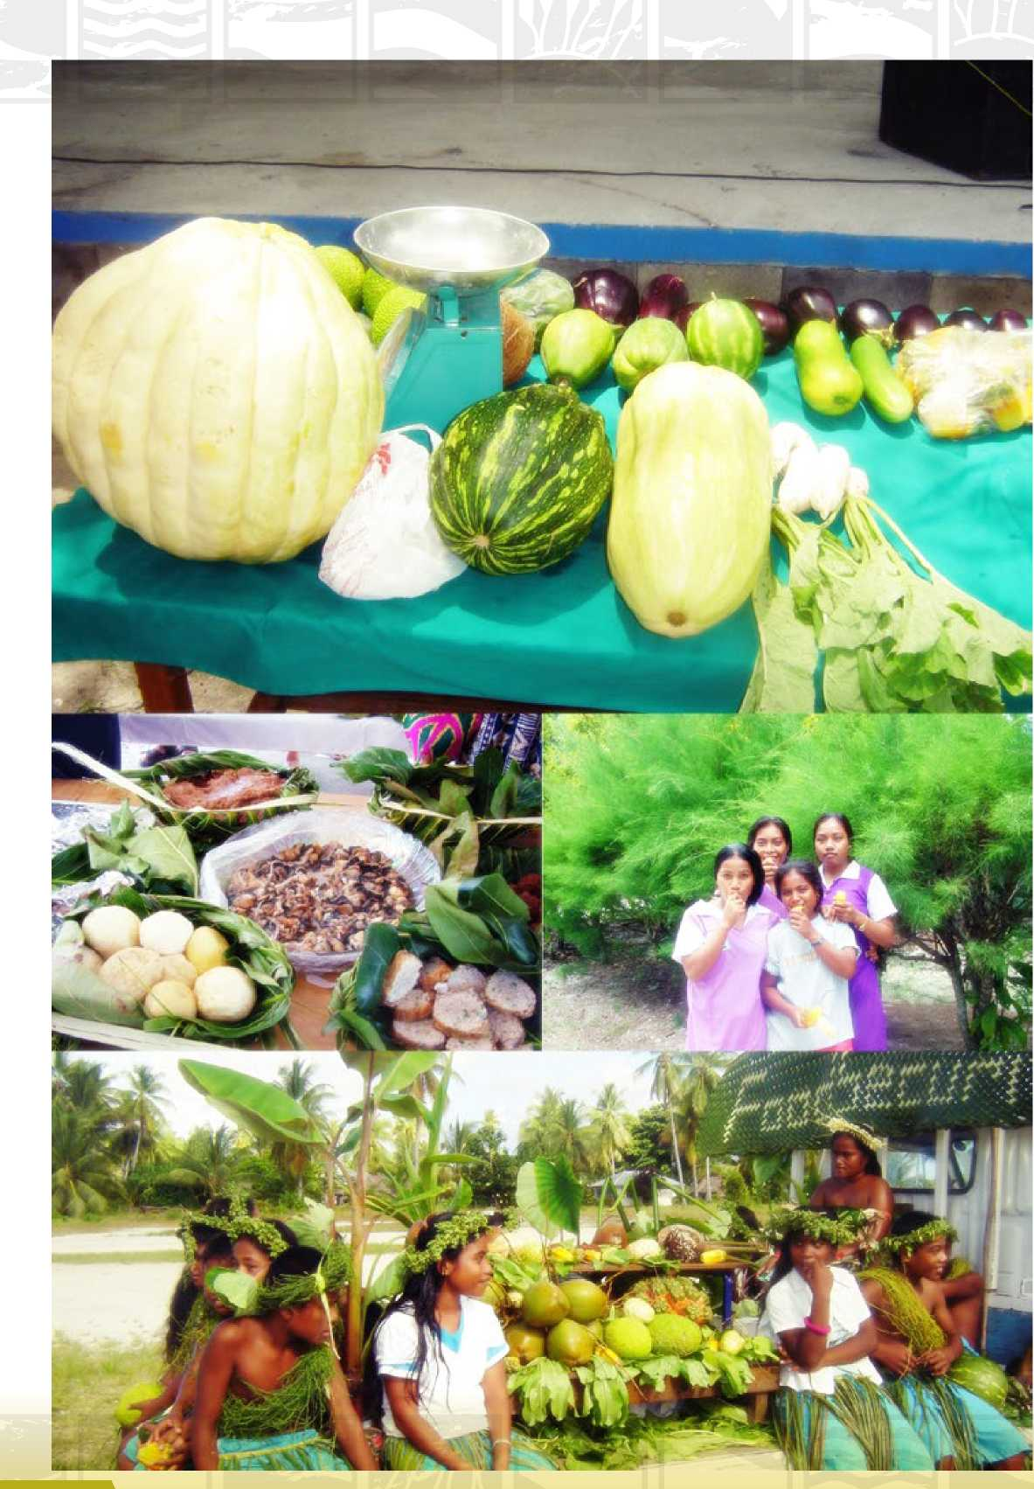

The vision of the Government of Kiribati is ‘A vibrant economy for the people of Kiribati’. The line ministries’ strategies are aligned towards this vision and are linked to the six broad key policy areas (KPAs) of the 2008 to 2011 plan. The agricultural strategy of ALD is aligned to KPA 2 and KPA 4.

03

VISION & OBJECTIVES

1. KPA 1: Human resource development
2. KPA 2: Economic growth and poverty reduction
3. KPA 3: Health
4. KPA 4: Environment
5. KPA 5: Governance
6. KPA 6: Infrastructure

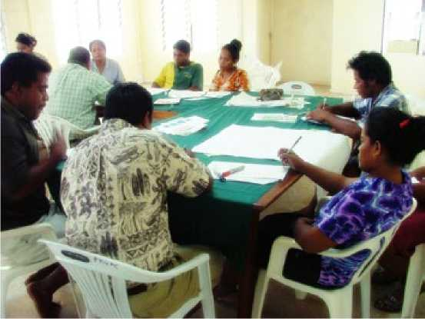Farmers must be helped to grow a diverse range of crops, not just babai and bananas. A direct consequence of increased food production is a corresponding increase in food security. An analysis of the food supply in 2005 found that 64% of food available in Kiribati that year was imported, indicating vulnerability with respect to food security. The vulnerability will be further increased by impacts of climate change.

Goal

The goal derived from the above vision is: Households of Kiribati have food, income and nutrition security and the balance of the agricultural and forestry environment is sustained and maintained.

The key performance indicators:

* Contribution of local food to the diet increased
* Contribution of agriculture to households’ income increased
* Incidence of dietary diseases reduced
* Crop and livestock diversity increased

Objectives

The ALD will focus on four key objectives for the period 2013-2016:

* Objective 1: Sustainable atoll crop production systems developed and promoted
* Objective 2: Sustainable small animal livestock systems developed and promoted
* Objective 2: Improved biosecurity
* Objective 3: Capacity building for stakeholders and agricultural staff

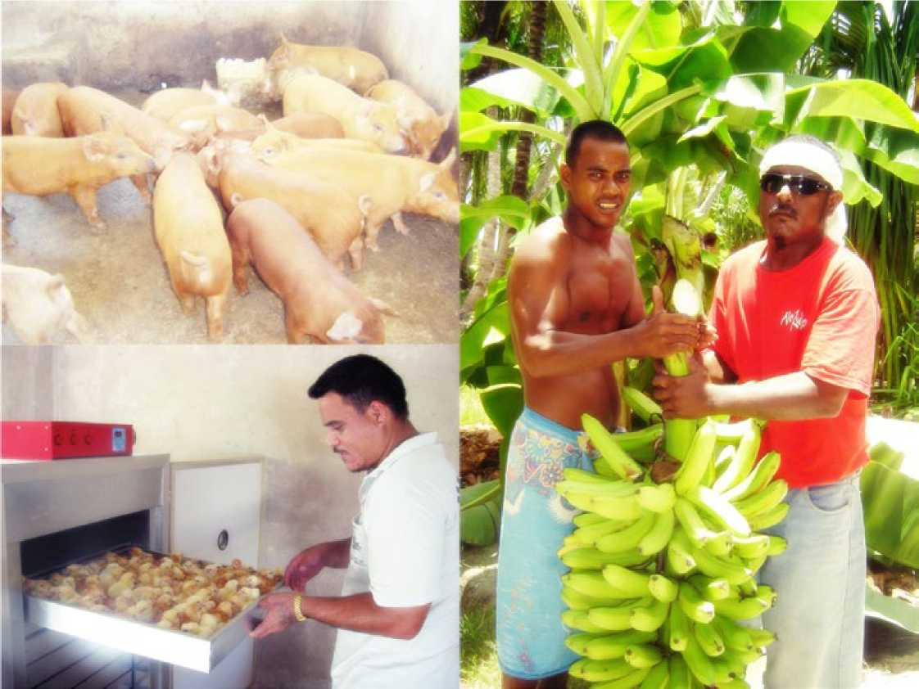

OUTPUTS

04

This section outlines the most significant outputs for the period 2013-2016. A range of strategies will be implemented, and they are interrelated in their effects. The implementation of any one strategy will both help to achieve and be helped by the implementation of the other strategies.

Some of the strategies, when implemented, will contribute to achieving more than one objective. The outputs are grouped under the four objectives.

Objective 1:

Sustainable atoll crop production systems developed and promoted

The key performance indicators:

* Increased adoption of sustainable management systems
* Increase in crop area and production

Output 1.1:

Crop diversity improved, conserved, and utilised

Improving crop diversity, especially among traditional crops that are less demanding in terms of production inputs compared to improved exotic crops, will result in the production of cheaper food as well as raising incomes. Selecting varieties that are more adaptable to harsh atoll conditions and potential climate change impacts of increased temperature, drought, and seawater intrusion will ensure the development of more sustainable production systems that are more environmentally friendly. ALD will initiate activities to ensure that genetic diversity of crops is conserved. Efforts will be made to link agricultural production to health and nutrition.

Output 1.2:

Soil management technologies appropriate for atoll conditions developed and adopted

The soils are calcareous, shallow, alkaline and coarse textured. Any sustainable soil management technologies workable on atoll soils of Kiribati will have to improve the soil’s physical, chemical and biological properties. This means that the efforts will be on improving soil organic matter by use of composting, adaptable cover crops, and any other intervention that will recycle organic matter back to the soil. This will provide opportunity for soil carbon sequestration.

Output 1.3:

Agroforestry systems appropriate for atolls developed and adopted

The Crop Production and Agroforestry Section of ALD will work towards the development of agroforestry systems utilising traditional trees and adaptable exotic trees in combination with traditional staple crops and small livestock. The ultimate aim is to develop integrated and holistic food production systems resilient to impacts of climate change and contributing to food security.

Output 1.4:

Water management technologies appropriate for atolls developed and adopted

This output is linked to Outputs 1.2 and 1.3. When organic matter levels in soils are improved, the soils will hold more water for plant use. An integrated agroforestry system will also reduce the water required for food production. But if farmers are to grow cash crops like vegetables (lettuce, cucumber and cabbages), then they must have access to reliable water sources. This will mean that ALD will promote a drip irrigation system like the bucket irrigation system that was promoted by the DSAP (Development of Sustainable Agriculture in the Pacific) project.

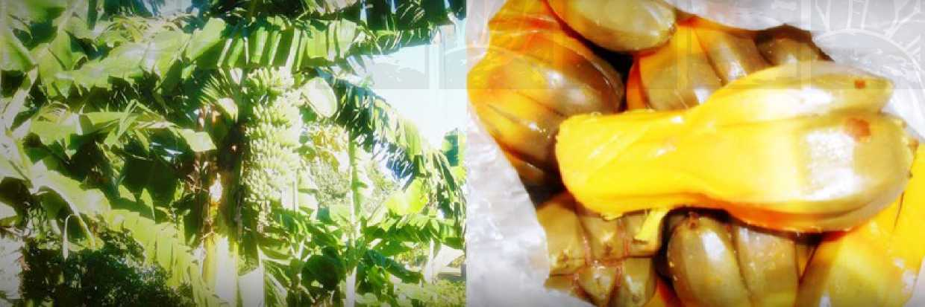

**Output 1.5:**

**Pest and disease problems identified, control methods developed and promoted, and capacity to respond to pest problems strengthened**

There is a need to strengthen the capacity of ALD in the area of biosecurity so that it can manage plant and animal pests and diseases and weeds on a day-to-day basis. It is important that the diagnostic skills of both ALD staff and farmers and their ability to test solutions on-farm are strengthened. Investigation into the potential development of a new pest and disease regime addressing impacts of climate change will be undertaken with capacity support from the Secretariat of the Pacific Community (SPC) and other international agencies such as the Food and Agriculture Organization of the United Nations (FAO) and the Australian Centre for International Agricultural Research (ACIAR). Since Kiribati advocates no use of inorganic pesticides, it should develop organic food production systems. ALD should seek capacity building support in this area from SPC and FAO.

Objective 2:

Sustainable small-animal livestock production systems developed and promoted

The key performance indicators:

* Increased adoption of sustainable livestock management systems
* Increase in livestock numbers and production
* National waste management strategies developed and adopted

Output 2.1:

Appropriate livestock management practices developed and promoted

ALD will seek support for capacity building in the development and promotion of sustainable improved livestock management practices, including animal pest and disease control and waste management strategies. Many of the challenges facing ALD are interwoven, and significant benefits can be gained from closer integrated efforts with other stakeholders, including SPC and FAO.

Output 2.2:

Livestock genetics diversified, improved, conserved and utilised

There are limited choices for livestock production in Kiribati. Most common are smaller animals - pigs, poultry and ducks. The traditional breeds of small animals raised on atolls are disappearing. The recommended strategy is to improve the local breeds by crossing with good breeds that can adapt to Kiribati conditions, taking into consideration also the potential impacts of climate change.

Output 2.3:

Livestock feeds with local ingredients developed

Livestock feeds are very expensive, making cost of livestock production too high. There is therefore a need for ALD to seek capacity building in making livestock feeds from local ingredients or making the feeds locally with combination of local and imported materials.

Output 2.4:

Livestock waste management improved

Piggery waste is a problem in Kiribati, especially along the coastal areas. This activity is linked to Output 1.2. Piggery waste should be used as one of the ingredients for composting to be used in crop production. ALD should explore spearheading a national campaign on waste management for a cleaner environment and better crop nutrition.

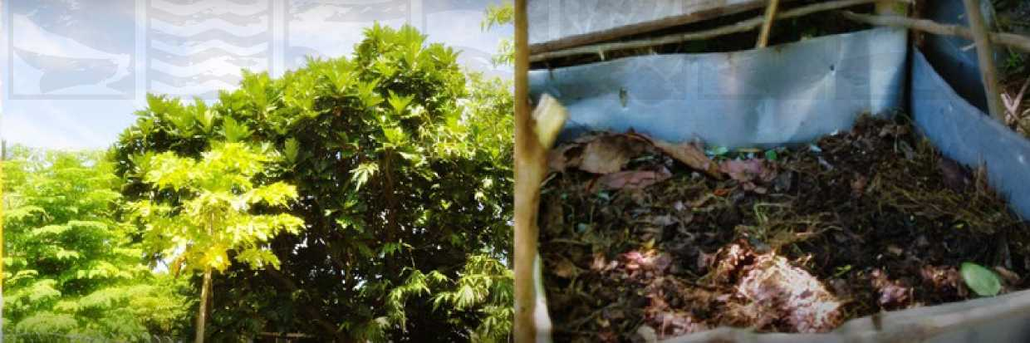

Objective 3:

Improved biosecurity

The key performance indicators:

* Compliance with international standards
* Enactment of biosecurity bills
* Increase in domestic and export trade
* Plant protection programme operational (linked to Output 1.5)

Output 3.1:

Capacity to increase domestic and export trade developed and strengthened

Biosecurity staff will be supported by the Pacific Plant Protection Organisation (PPPO), SPC Land Resources Division (LRD) Plant Health Group and FAO to comply with international standards through training in import risk assessment and import specifications, accessing markets, updating national pest lists, and issuing phytosanitary and animal health certificates for export commodities.

Capacity to carry out commodity pathway analyses will also be strengthened.

Output 3.2:

Quarantine/biosecurity capacity improved

Efforts will be made to sustain a low pest prevalence while facilitating trade. Border security is the first line of defence against the introduction of exotic pests and diseases. The staff will be trained in different aspects of quarantine and pest and disease identification and control.

Objective 4:

Capacity building for stakeholders and agricultural staff

The key performance indicators:

* Efficient agricultural staff
* Skilled stakeholders

Output 4.1:

Farming and business skills of farmers improved

Farming is predominantly for subsistence in Kiribati. In order to commercialise operations, there is a need to build the farming and business skills of the farming community, with special emphasis on youth and women.

Output 4.2:

Capacity of extension, outreach, and information services strengthened

Currently ALD and other stakeholders have limited human resources and few people with adequate qualifications to efficiently implement key agricultural sector activities. There is also limited human resource development, including a general lack of vocational and academic training in agriculture and forestry.

It is very important that the national immersion extension outreach programme is strengthened and improved further, especially the information and knowledge management aspect of the system, to ensure quality delivery of ALD’s services to its clients.

Output 4.3:

Technical skills of agricultural staff improved

The participatory consultation with stakeholders highlighted the need to upgrade the technical skills of agricultural staff, especially their diagnostic skills. It is envisaged that an improvement in the diagnostic skills of staff will contribute significantly to properly addressing farmers’ problems. On-farm development of technologies will also be promoted. It will be necessary to ensure that from the beginning farmers are involved in problem diagnosis and in deciding on solutions to their problems, and that they are part of developing the technologies to solve their agricultural and forestry problems.

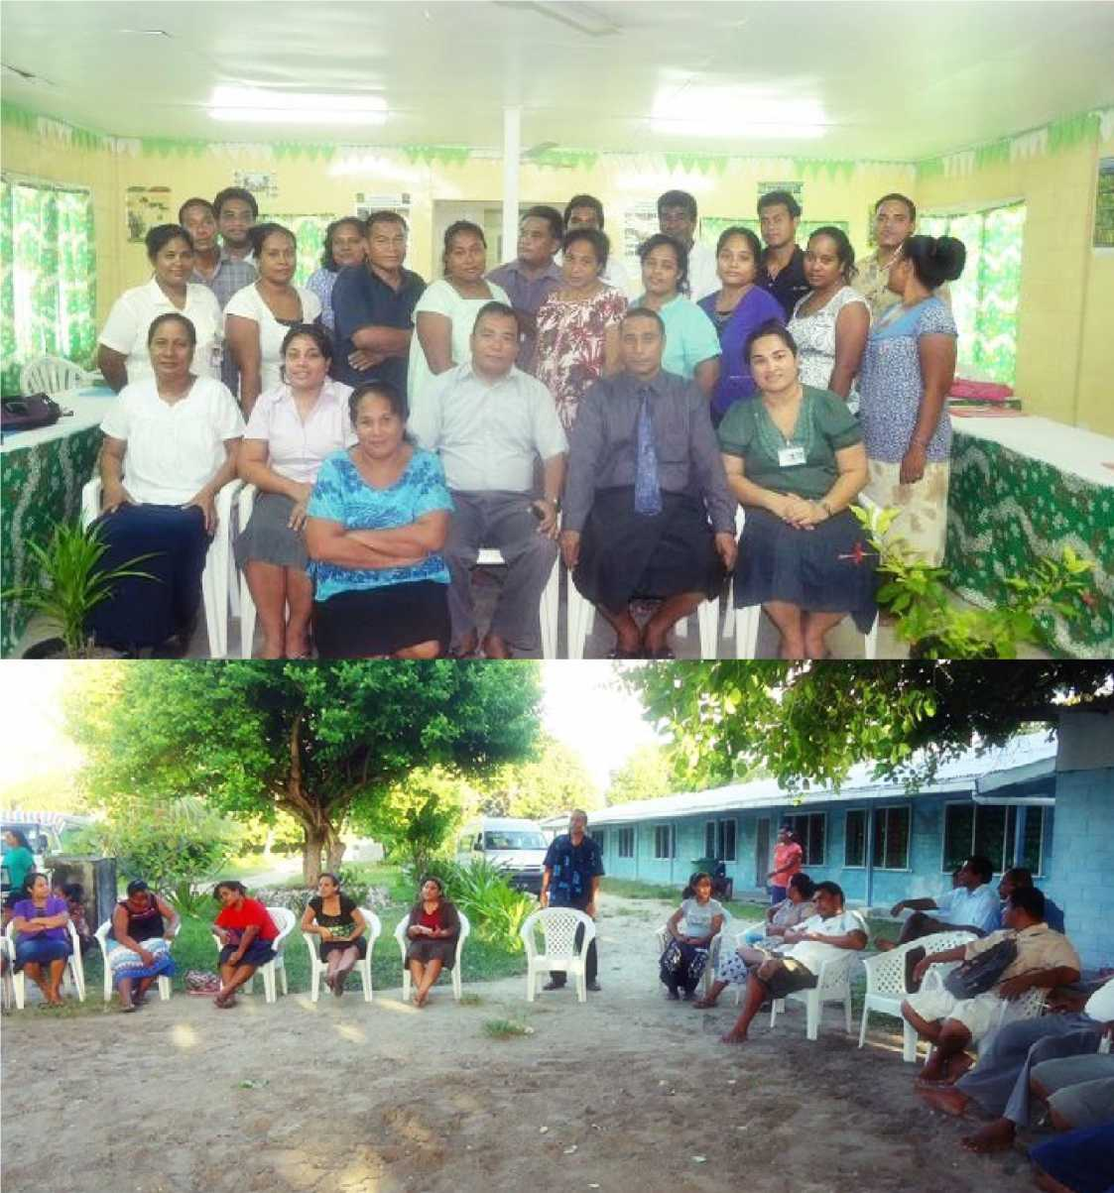

05

MONITORING & EVALUATION

Monitoring and evaluation is a powerful management tool that can be used by ALD policy-makers and decision-makers as well as all stakeholders to track progress and demonstrate the impacts of a given project, programme or policy. The monitoring should be results-based and move beyond an emphasis on inputs and outputs to a greater focus on outcomes and impacts. Results-based monitoring and evaluation is not easy to carry out but it can be done, and this strategic plan will endeavour to do so. The performance indicators for the plan’s objectives and goal imply that outcomes and impacts will be monitored in the plan.

Independent reviewers may be engaged to evaluate the plan in the middle and at the end of the plan period. Evaluations will assess results, impacts, and sustainability in light of the goal and objectives. In order to enable efficient monitoring and evaluation, baseline data for each performance indicator will be collected. Performance will be measured against these baseline data.

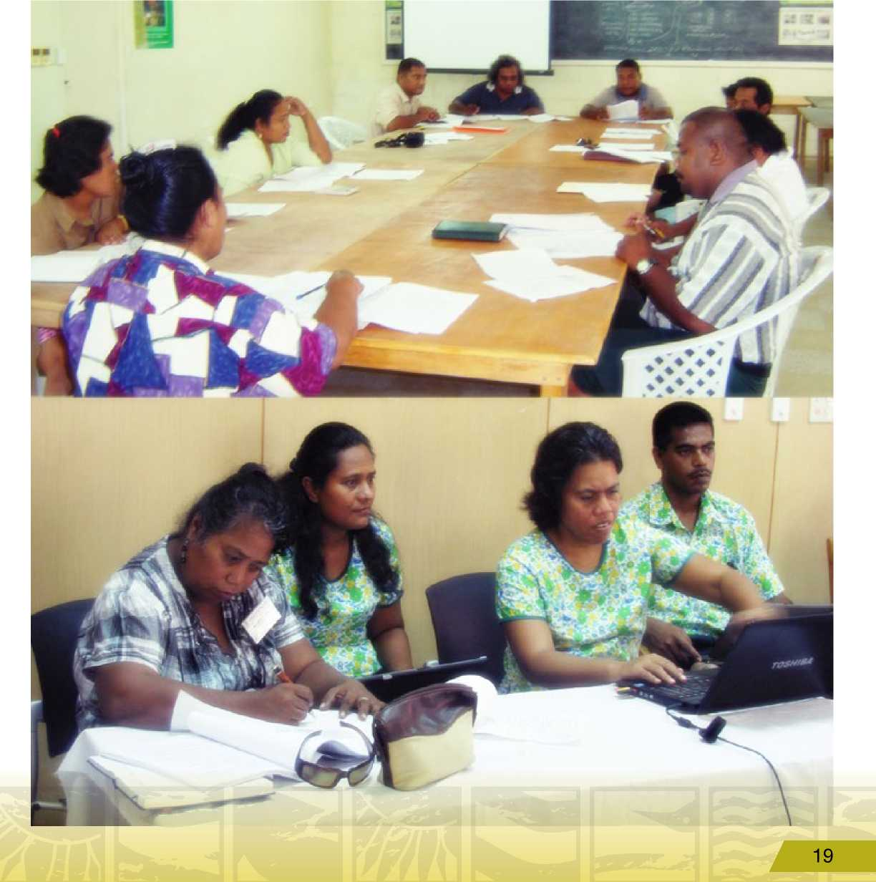

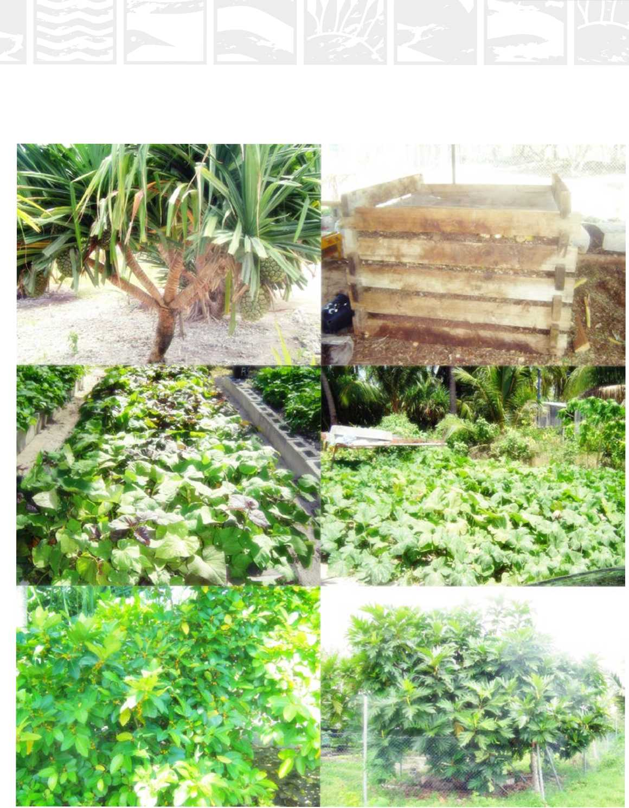

|  |  |  |
| --- | --- | --- |
| **Narrative** | **Performance Indicators** | **Means of Verification** |
| **Objective 1.**  **Sustainable atoll crop production systems developed and promoted** | * **Increased adoption of sustainable management systems** * **Increase in crop area and production** | * **Department reports** * **Statistics Department reports** * **Focus surveys** |
| Output 1.1:  Crop diversity improved, conserved, and utilised | * Adaptable crops selected * Number of nurseries and genebanks established * Increase in availability of seeds and planting materials | * Department reports * Project reports * Focus surveys |
| Output 1.2:  Soil management technologies appropriate for atoll conditions developed and adopted | • Soil organic matter management technologies generated and promote | • Department reports  • Project reports |
| Output 1.3:  Agroforestry systems appropriate for atolls developed and adopted | * Agroforestry technologies developed and adopted * Crop production technologies including hydroponics developed and promoted | • Department reports  • Project reports |
| Output 1.4:  Water management technologies appropriate for atolls developed and adopted | • A drip irrigation system developed and adopted | • Department reports  • Project reports |
| Output 1.5:  Pest and disease problems identified, control methods developed and promoted, and capacity to respond to pest problems strengthened | * Number of pests identified * Control measures developed and adopted * Increased productivity of staples * Emergency response plans developed and implemented | • Department reports |

06

LOGICAL FRAMEWORK MATRIX

|  |  |  |
| --- | --- | --- |
| **■ Narrative** | **Performance Indicators** | **Means of Verification** |
| **Objective 2: Sustainable small-animal livestock systems developed and promoted** | * **Increased adoption of sustainable livestock management systems** * **Increase in livestock numbers and production** * **National waste management strategies developed and adopted** | * **Department reports** * **Statistics Department reports** * **Focus surveys** |
| Output 2.1:  Appropriate livestock management practices developed and promoted | * Improved piggery management practices developed and adopted * Improved chicken and duck management practices developed and adopted | • Department reports  • Project reports |
| Output 2.2:  Livestock genetics diversified improved, conserved and utilised | * Improvement in animal breeds * Improved distribution of improved breeds | • Department reports  • Project reports |
| Output 2.3:  Livestock feeds with local ingredients developed | * Local ingredients identified and mass produced * Local or part-local ration developed | • Department reports  • Project reports |
| Output 2.4:  Livestock waste management improved | • Waste management strategies developed and adopted | • Department reports  • Project reports |
| **Objective 3:**  **Improved biosecurity** | * **Compliance with international standards** * **Enactment of biosecurity bills** * **Increase in domestic and export**   **trade**   * **Plant protection programme operational** | * **Ratifying conventions** * **Market access** * **Domestic market reports** |
| Output 3.1:  Capacity to increase domestic and export trade developed and strengthened | * Increase in domestic marketing of agricultural products * Commodity pathways established for two local products | * Domestic market reports * Commodity pathway report |
| Output 3.2:  Quarantine/ biosecurity capacity improved | * Number of pests intercepted * Biosecurity bills enacted and   implemented | * Department report * Press release * Gazetted bills |

|  |  |  |
| --- | --- | --- |
| **Narrative** | **Performance Indicators** | **Means of Verification** |
| **Objective 4:**  **Capacity building for stakeholders and agricultural staff** | **• Efficient agricultural staff • Skilled stakeholders** | **• Focus surveys** |
| Output 4.1:  Farming and business skills of farmers improved | * Number of farmers trained * Number of farmers efficiently applying skills | • Department reports  • Focus surveys |
| Output 4.2:  Capacity of extension, outreach, and information services strengthened | • Extension outreach information and innovation methods adopted | • Department reports |
| Output 4.3:  Technical skills of agricultural staff improved | * Number of technical skills training courses conducted * Number of staff trained * Number of staff efficiently applying skills | • Department reports  • Focus surveys |

24